**EXPORTING REQUIREMENTS**

It only works in “Requirements Grid View”

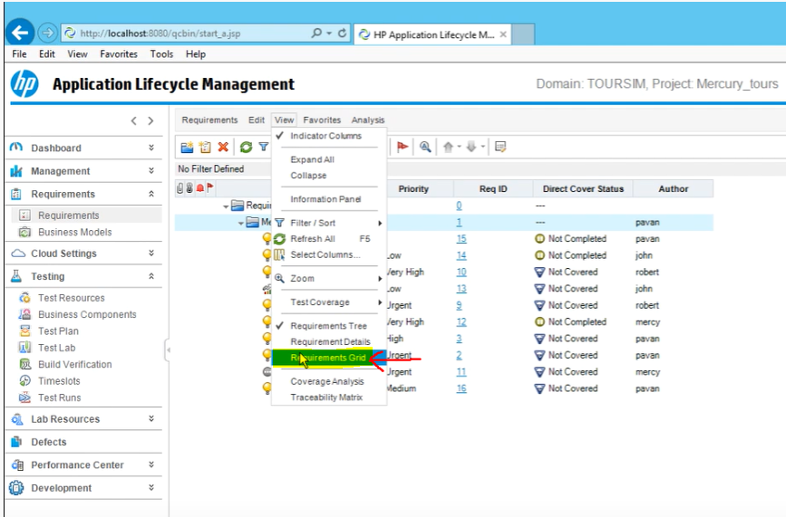

When you are on GRID VIEW, select your requirement, right click and export.

You can only export the selected requirement or ALL the requirements

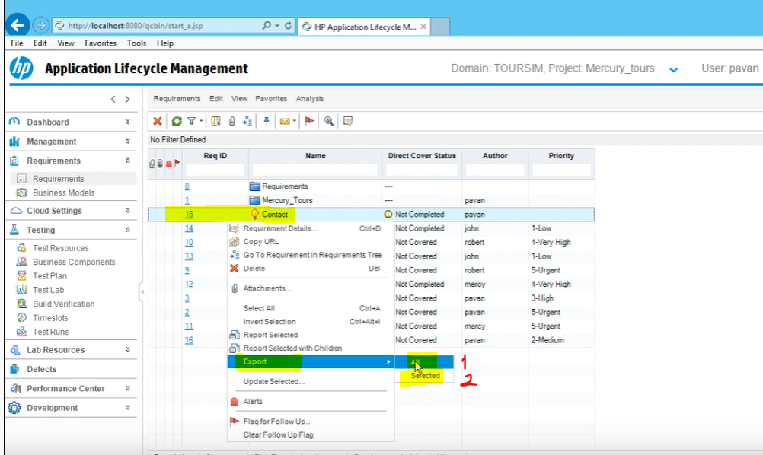

Then you can select the export location and file type

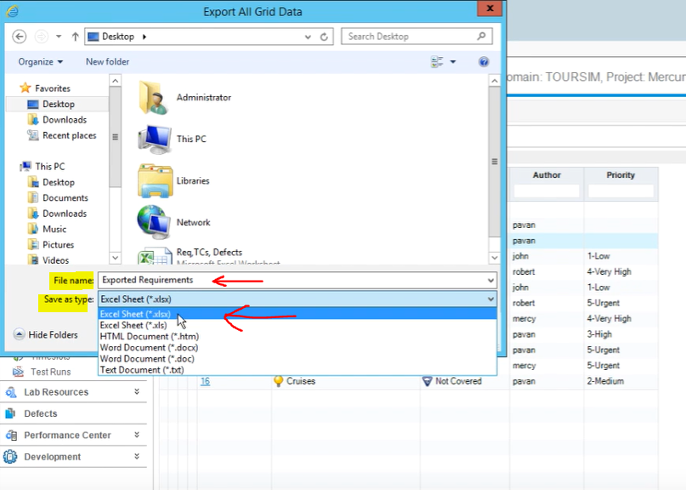

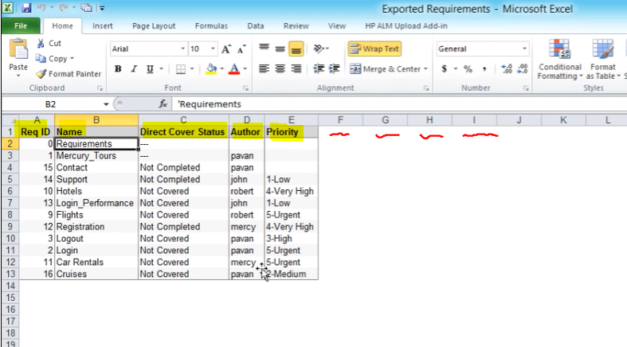

If you would like to have other columns about your requirements other than “Req ID, Name, Direct Cover Status, Author, Priority” you need to add Columns on ALM first then Export the requirements

That way, they will be added on your export.